Some limitations are that the card view is not clickable, and therefore the results screen is not working.

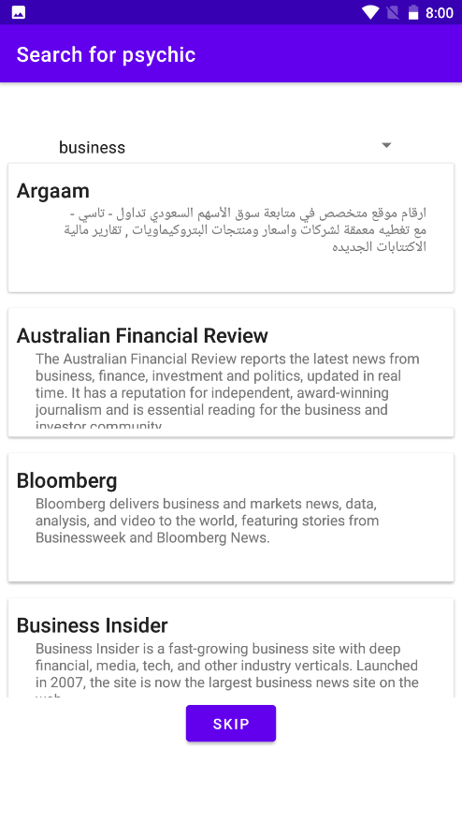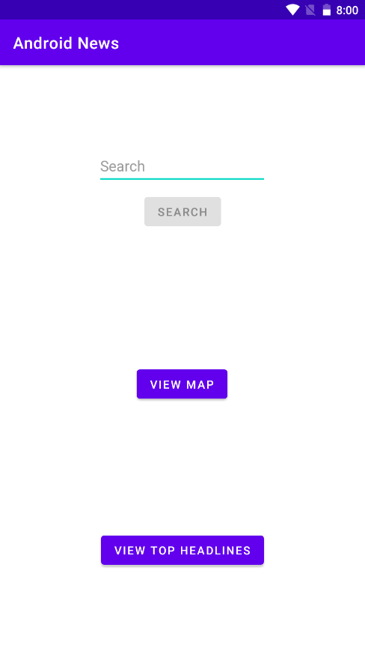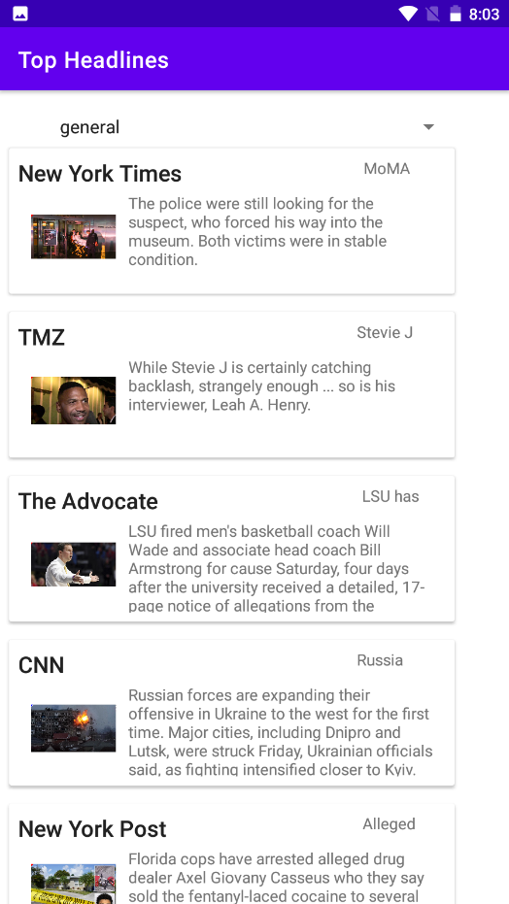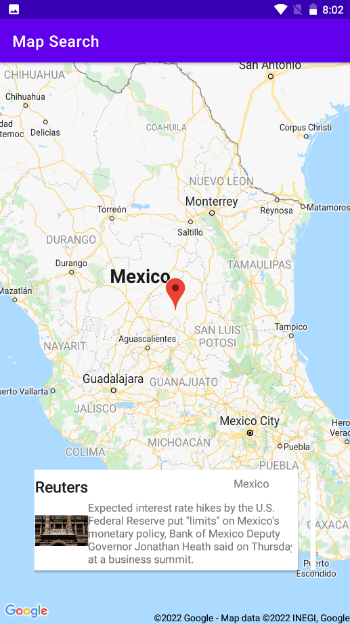Another limitation is that for the maps screen, it takes about two clicks on the same country to actually generate news from that country.